North Gloucestershire Orienteering Club

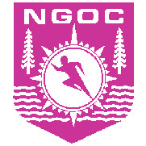

Code of Conduct for Club Officials and Volunteers

Effective from 30th November 2008

All volunteers must:

- Make sure all activities are appropriate to the age, ability and experience of those taking part.

- Develop an appropriate working relationship with juniors who take part in club activities, based on mutual trust and respect.

- Consider the well-being and safety of participants.

- Promote the positive aspects of the sport (e g exercise, fair play and respect for the countryside).

- Display consistently high standards of behaviour and appearance.

- Follow all guidelines laid down by British Orienteering and the Club.

- Hold the appropriate, valid qualifications and insurance cover.

- Never condone bad behaviour or the use of prohibited substances.

